SRM ARTS AND SCIENCE COLLEGE-KATTANKULATHUR

DEPARTMENT OF ELECTRONICS AND COMMUNICATION SCIENCE

**INDIA’S AGRICULTURAL CROP PRODUCTION ANALYSIS (1997-2021)**

**TEAM MEMBERS**

1. D.SHARMILA

2. K.GAYATHRI

3. MANDADI VARSHA

4. KARRI RAMYA TEJA SRI

**TABLE OF CONTENT**

**1. INTRODUCTION**

1.1 OVERVIEW

1.2 PURPOSE

**2. PROBLEM DEFINITION & DESEIGN THINKING**

2.1 EMPATHY MAP

2.2 IDEATION & BRAINSTORMING MAP

**3. RESULT**

**4. ADVANTAGES & DISADVANTAGES**

**5. APPLICATIONS**

**6. CONCLUTION**

**7. FUTURE SCOPE**

**1.INTRODUCTION**

1.1 OVERVIEW

In this project our aim is to comprehensively analyze the India’s crop production over the years of 1997 to 2021. To analyze our project in various dimensions like years of cultivation, types of crops, percentage of productions etc…We are going to analysis the dataset collected by using data visualization tool of tableau. Based on the information obtained using the data visualization tool of tableau, we can understand the recent trend and predict the future trend.

1.2 PURPOSE

Our purpose is to analyze the trend of the crop production and productivity in various region of India.

**2.PROBLEM DEFINITION & DESEIGN THINKING**

2.1 EMPATHY MAP

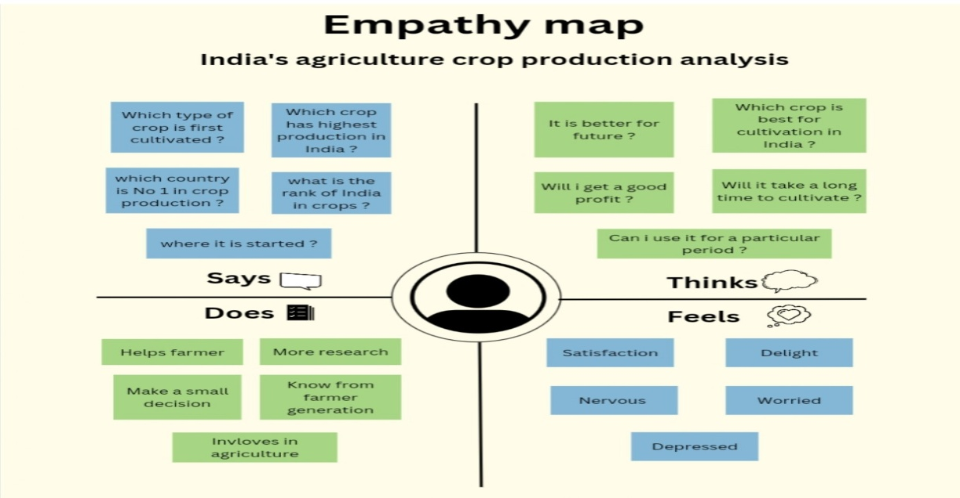

2.1 BRAINSTROMING MAP

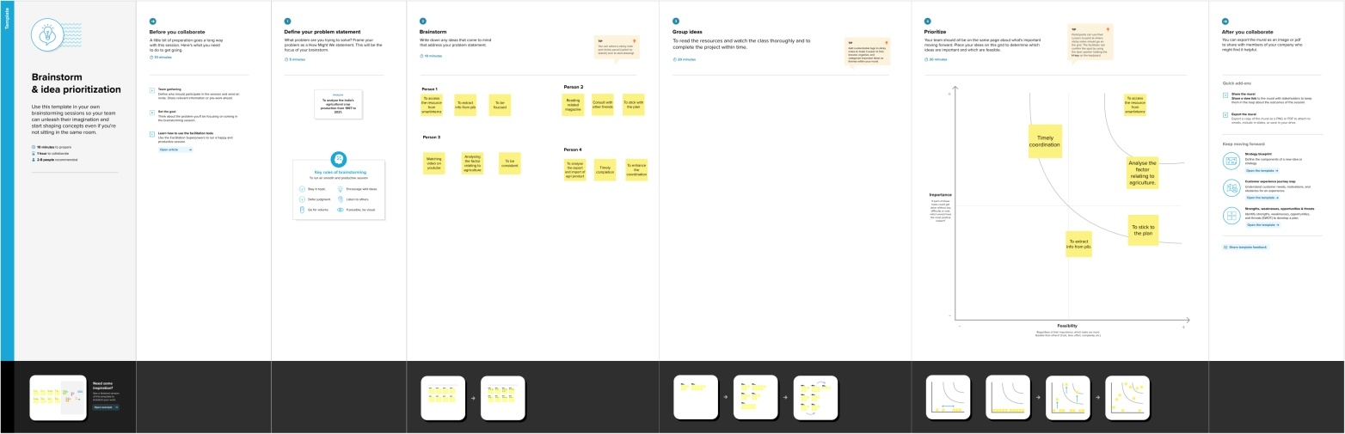

**3.RESULT**

* Uttar Pradesh is renowned for having the highest area of crop production in India.
* This crop is widely regarded as the most favored by the inhabitants of India.
* Ragi is not a preferred crop; it accounts for a mere 0.20% of the crop.
* In terms of area and percentage, rice is India's most widely planted crop.
* Among the 20 crops that are grown in India, we have counted the plantations for agricultural production.
* The main crops in the 2012–2013 growing season.
* The highest production, seasonally, occurs in kharif.

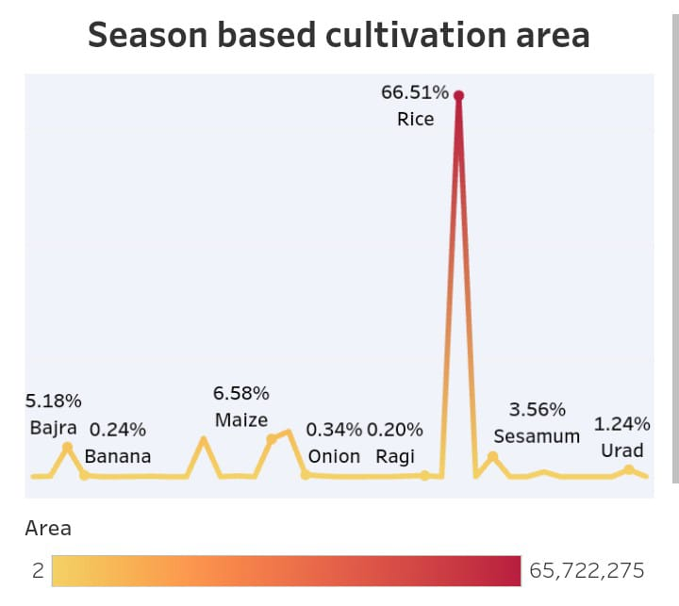**Season based cultivation crop**

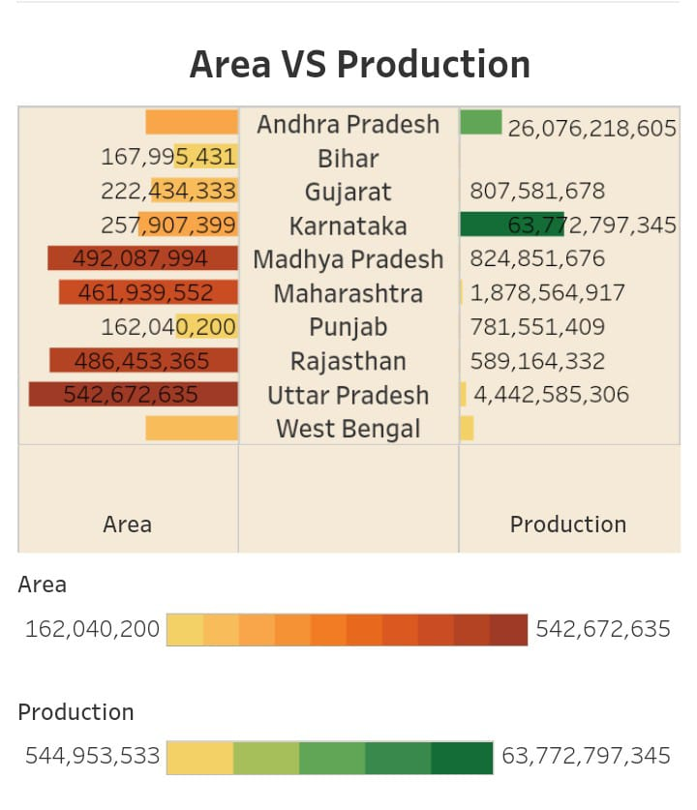

**Area vs production**

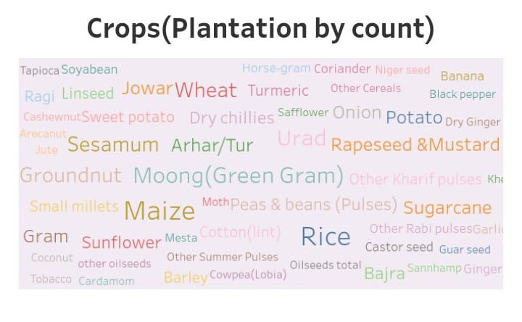 **Crops(plantation by count)**

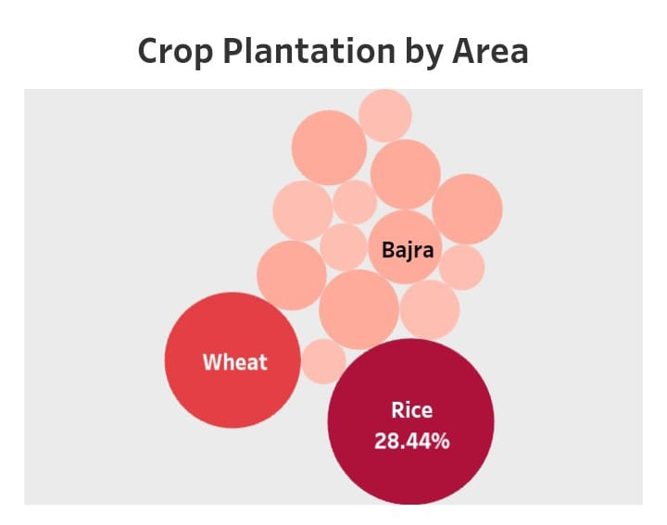

**Crop plantation by area**

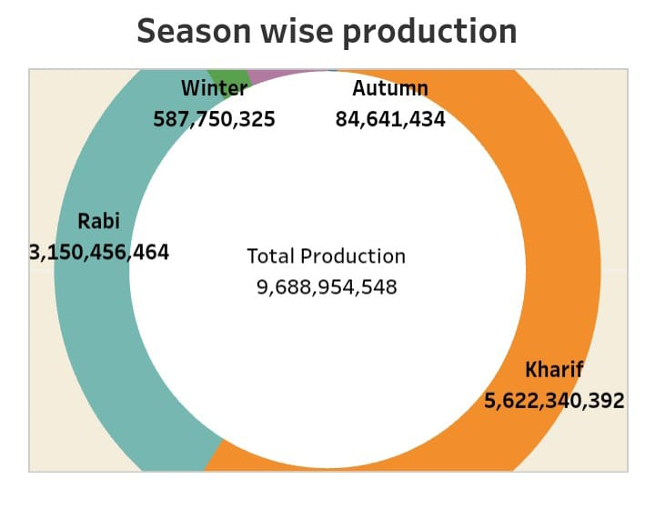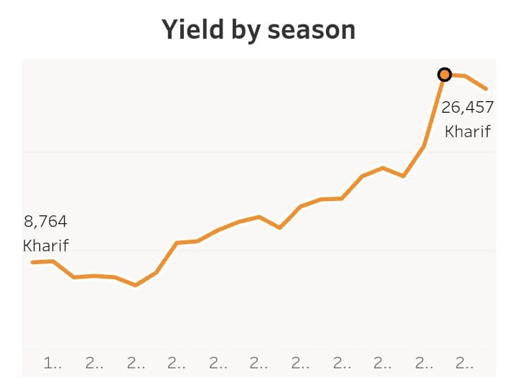

**Season wise production Yield by season**

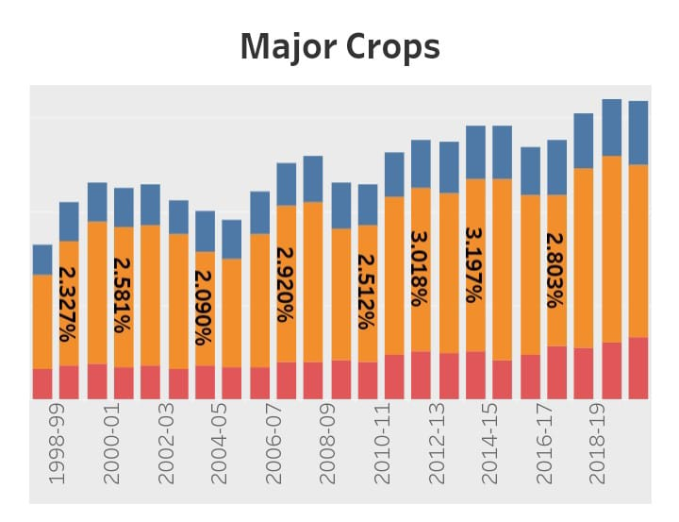

**Major crops**

**4.ADVANTAGES AND DISADVANTAGES**

* It will inform the farmers what crop to been shown in a particular season.
* It will also help the consumers by informing them by availability of food grains.
* It will help the farmers by showing the food grain that is best suitable for them.
* We have taken only a few number of food grains in the conservation.

**5.APPLICATIONS**

This category includes fertilizers, herbicides, pesticides, rodenticides, fumigants and other inputs/applications for improved agricultural performance. It will inform the farmers what crop to been shown in a particular season. It will also help the consumers by informing them by availability of food grains.

**6.CONCLUSION**

So far, we have used the collected data to analyze the India’s agricultural crop production(1997-2021) and have depicted the same using the data visualization tool of tableau software. We have developed a dashboard and story using which the analysis can be made user friendly and interactive.

**7.FUTURE SCOPE**

There are so much avenues for future development on your project analysis and one such future development, to overcome the present disadvantages, is increasing the sample space taken for research say, we have taken only a few number of food grains in the conservation. So we can include more number of food grains into our analysis.